**God who provides**

**Genesis 22:7-8, 13-14**

Isaac said to his father Abraham, “Father!” Abraham answered, “Yes son?”

Isaac said, “I see the wood and the fire. But where is the lamb we will burn as a sacrifice?”

Abraham answered, “God himself is providing the lamb for the sacrifice, my son.”

Then Abraham noticed a ram whose horns were caught in a bush. So, Abraham went and took the ram. He offered it, instead of his son, as a sacrifice to God. So, Abraham gave that place a name, “The Lord Provides.”

**Thought about the reading**

This story took place a long time ago**,** many years before Jesus was born. At that time, people would kill an animal to please God, and to show him that they were sorry for the things they had done wrong. This was called a sacrifice.

Abraham was a special person who wanted to do what God told him. God told him to use his son as a sacrifice, instead of an animal. Abraham was very sad, because he loved his son, but he set off to do what God told him.

Abraham was ready to sacrifice his son, but God stopped him and showed him a ram caught in the bushes. Abraham offered the ram to God as a sacrifice, instead of his son. He called the place where it happened, “The Lord provides”, because he learnt that God provides what we need.

God is still the God who provides, and he will provide all we need. He will give us the help we need when things are difficult.

**Prayer**

Father God, thank you that you are the God who provides all we need.

Thank you that you give us all the help we need when things are difficult.

Please help me to trust you, just as Abraham trusted you.

Amen

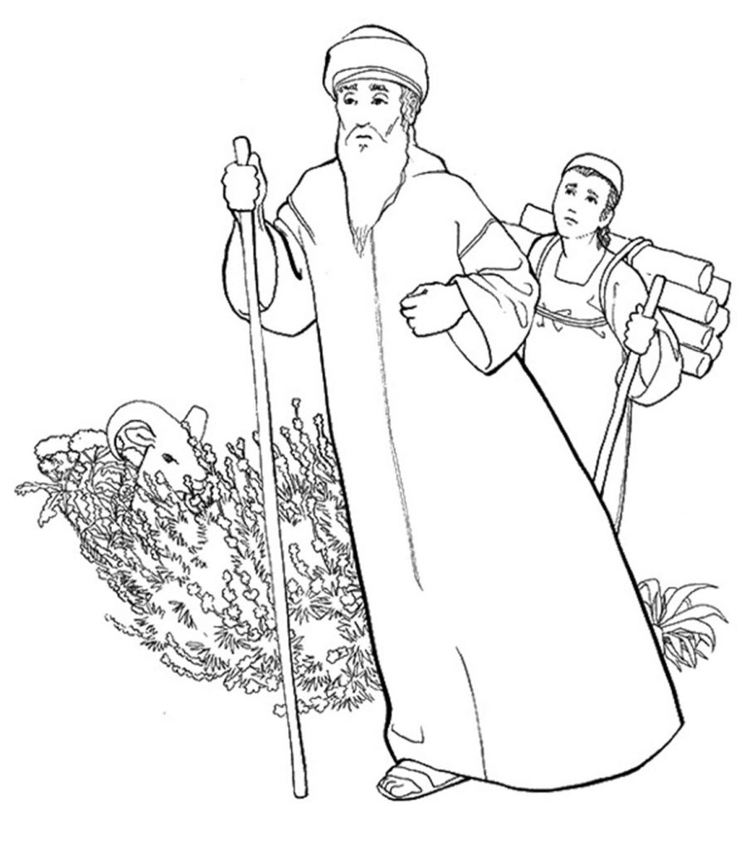

**Cambridge Causeway**

Spring 2022

Bible Study notes

**Names of God**

**4. God who provides**

By Chrissy Cole